HW2

Due Date: Dec. 3, 2018
Submission requirements:
Please submit your solutions to our class website.

Part I: written assignment

1．Consider the data set shown in Table 1（min_sup = 60%, min_conf=70%）.
- Find all frequent itemsets using Apriori by treating each transaction ID as a market basket.
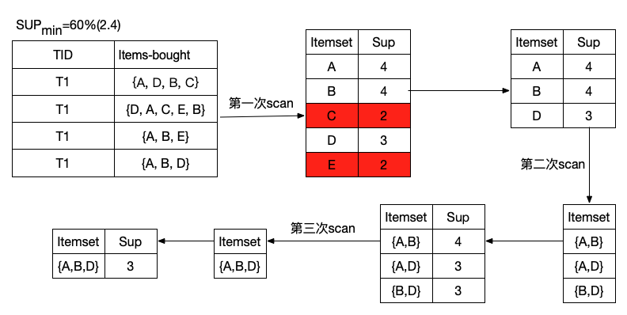
- Use the results in part (a) to compute the conﬁdence for the association rules {a, b}→{c} and {c}→{a, b}. Is conﬁdence a symmetric measure?
{a, b}→{c} (50%,100%)
{c}→{a, b} (50%,50%)
The confidence is not symmetric
- List all of the strong association rules (with support s and confidence c) matching the following metarule, where X is a variable representing customers, and item_{i} denotes variables representing items (e.g. “A”, “B”, etc.):

Table 1. Example of market basket transactions.

TID | Items-bought
T1 | {A, D, B, C}
T2 | {D, A, C, E, B}
T3 | {A, B, E}
T4 | {A, B, D}

2．Consider the data set shown in Table 1（min_sup = 60%）.
(a) Find all frequent itemsets using FP-Growth. Please present all the FP-trees and all the conditional pattern bases.
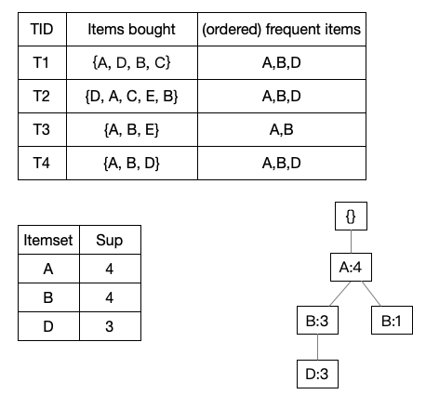
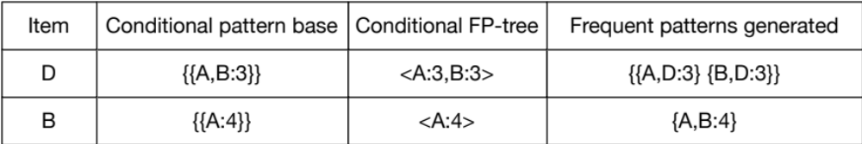
(b) Compare the efficiency of Apriori and FP-Growth.

- (a) Design a multilayer feed-forward neural network (one hidden layer) for the training data set in Q4 in hw1. Label the nodes in the input and output layers.
- Using the neural network obtained above, show the weight values after one iteration of the back propagation algorithm, given the training instance “(Medium, Blond, Blue, C1)". Indicate your initial weight values and biases and the learning rate used.

4. Suppose that the data mining task is to cluster the following ten points (with(x, y, z) representing location) into three clusters:
A1(4,2,5), A2(10,5,2), A3(5,8,7), B1(1,1,1), B2(2,3,2), B3(3,6,9), C1(11,9,2),C2(1,4,6), C3(9,1,7), C4(5,6,7)
The distance function is Euclidean distance. Suppose initially we assign A1,B1,C1 as the center of each cluster, respectively. Use the K-Means algorithm to show only
- The three cluster center after the first round execution
{A1, C2, C4, C3, B3, A3} {B1, B2} {C1,A2}
- The final three clusters
{A1, C2, C4, C3, B3, A3} {B1, B2} {C1,A2}

Part II: Lab
Question 1
Learn the use of market basket analysis for the purpose of making product purchase recommendations to the customers.
The data set contains transactions from a large supermarket. Each transaction is made by someone holding the loyalty card. We limited the total number of categories in this supermarket data to 20 categories for simplicity. The field value for a certain product in the transaction basket is 1 if the customer has bought it and 0 if he/she has not. The file named “Transactions” has data for 46243 transactions.
The data are available from the class web page.
Your submission should consist only of those deliverables marked indicated by “Hand-in”.
Market basket analysis has the objective to discover individual products, or groups of products that tend to occur together in transactions. The knowledge obtained from a market basket analysis can be employed by a business to recognize products frequently sold together in order to determine recommendations and cross-sell and up-sell opportunities. It can also be used to improve the efficiency of a promotional campaign.

Run Apriori on “transaction” data set. Set the “Type” of “COD” as “Typeless”, set the “direction” of all the other 20 categories as “Both”, set their “Type” as “Flag”. Set “Minimum antecedent support” to be 7%, “Minimum confidence” to be 45%, and “Maximum number of antecedents” to be 4 in the modeling node (Apriori node). In general you should explore by trying different values of these parameters to see what type of rules you get.

- Hand-in: The list of association rules generated by the model.
Sort the rules by lift, support, and confidence, respectively to see the rules identified.

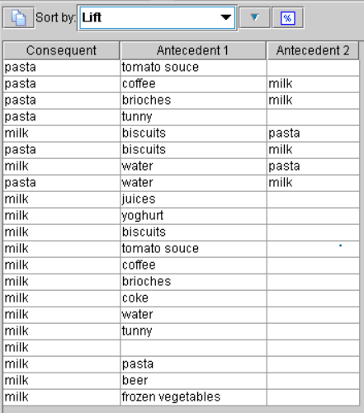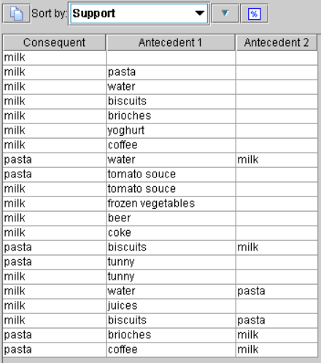
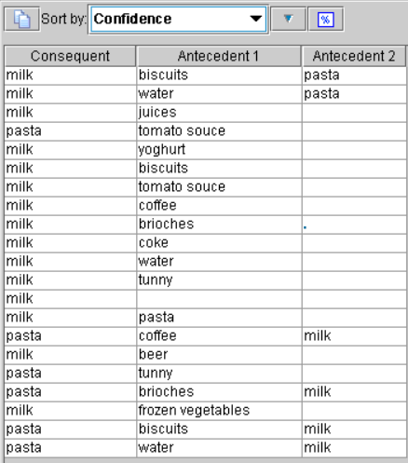
Hand-in: For each case, choose top 5 rules (note: make sure no redundant rules in the 5 rules) and give 2-3 lines comments. Many of the rules will be logically redundant and therefore will have to be eliminated after you think carefully about them.

Question 2

Churn Management
The goal of this assignment is to introduce churn management using decision trees, logistic regression and neural network. You will try different combinations of the parameters to see their impacts on the accuracy of your models for this specific data set. This data set contains summarized data records for each customer for a phone company. Our goal is to build a model so that this company can predict potential churners.
Two data sets are available, churn_training.txt and churn_validation.txt. Each data set has 21 variables. They are:

State:
Account_length: how long this person has been in this plan
Area_code:
Phone_number:
International_plan: this person has international plan=1, otherwise=0
Voice_mail_plan: this person has voice mail plan=1, otherwise=0
Number_vmail_messages: number of voice mails
Total_day_minutes:
Total_day_calls:
Total_day_charge:
Total_eve_minutes:
Total_eve_calls:
Total_eve_charge:
Total_night_minutes:
Total_night_calls:
Total_night_charge:
Total_intl_minutes:
Total_intl_calls:
Total_intl_charge:
Number_customer_service_calls:
Class: churn=1, did not churn=0
Each row in “churn_training” represents the customer record. The training data contains 2000 rows and the validation data contains 1033 records.
- Perform decision tree classification on training data set. Select all the input variables except state, area_code, and phone_number (since they are only informative for this analysis). Set the “Direction” of class as “out”, “type” as “Flag”. Then, specify the “minimum records per child branch” as 30, “pruning severity” as 60, click “use global pruning”. Hand-in the confusion matrices for validation data.
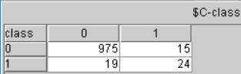
- Perform neural network on training data set using default settings. Again, select all the input variables except state, area_code, and phone_number. Hand-in the confusion matrix for validation data.
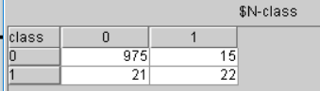
- Perform logistic regression on training data set using default settings. Again, select all the input variables except state, area_code, and phone_number. Hand-in the confusion matrix for validation data.
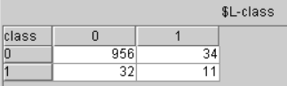
Hand-in your observations on the model quality for decision tree, neural network and logistic regression using the confusion matrices.

